ASSIGNMENT DAY-2

Name-Srujan

1)Write a program to print the following pattern

1

2\*2

3\*3\*3

4\*4\*4\*4sol:-

#include <stdio.h>

int main()

{

int i,j;

for(i=1;i<=4;i++)

{

for(j=1;j<=2\*i-1;j++)

{

if(j%2!=0)

{

printf("%d",i);

}

else{

printf("\*");

}

}

printf("\n");

}

}

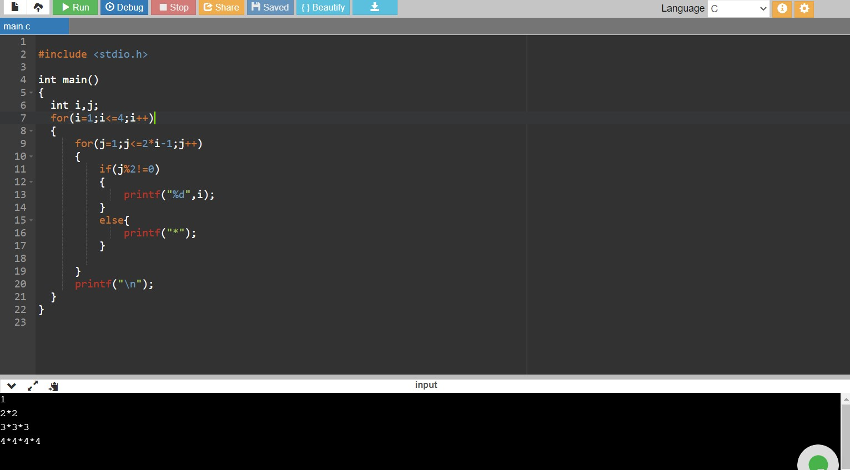

2)

Write a program to print the following pattern

1

01

101

0101

10101

Sol:-

#include <stdio.h>

int main()

{

int i,j;

for(i=1;i<=5;i++)

{

for(j=1;j<=i;j++)

{

if(i%2!=0)

{

if(j%2!=0)

{

printf("1");

}

else{

printf("0");

}

}

if(i%2==0)

{

if(j%2!=0)

{

printf("0");

}

else{

printf("1");

}

}

}

printf("\n");

}

}

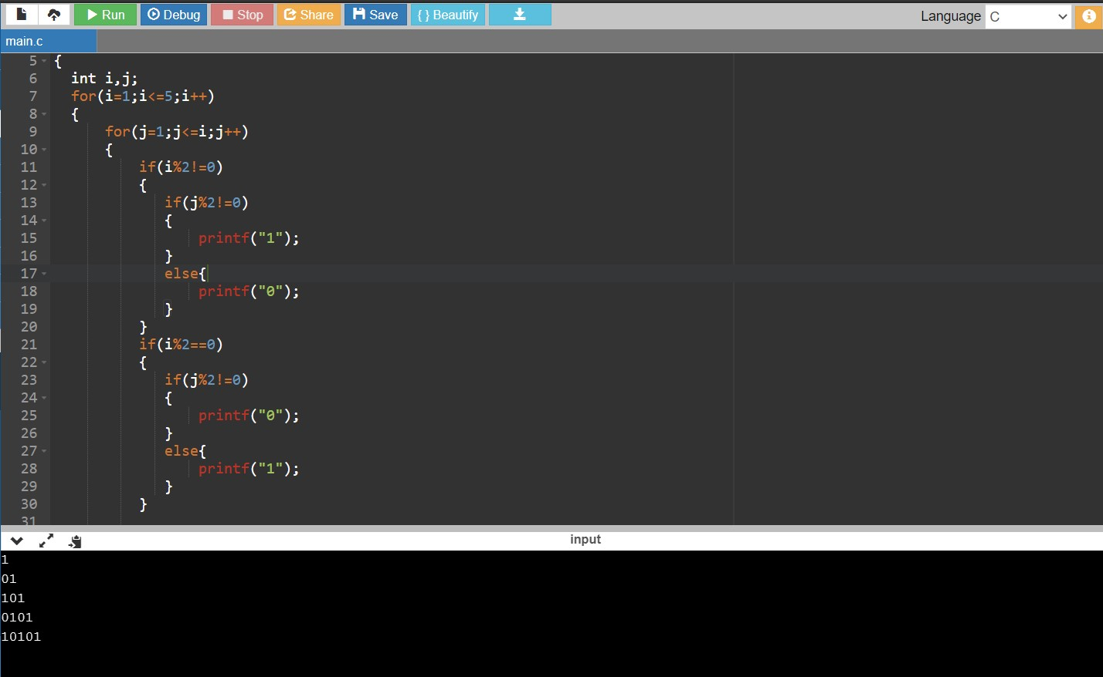

3)

Array in C is used to store elements of same types whereas Pointers are address variables which stores the address of a variable. Now array variable is also having a address which can be pointed by a pointer and array can be navigated using pointer